**Stephen Edward Ng PDA Evidence**

|  |  |
| --- | --- |
| I & T | I.T 5 |

**Array**

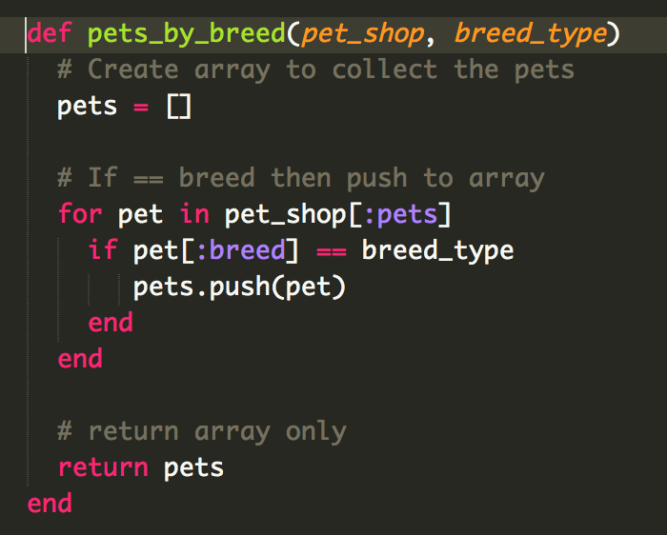

Test using the array

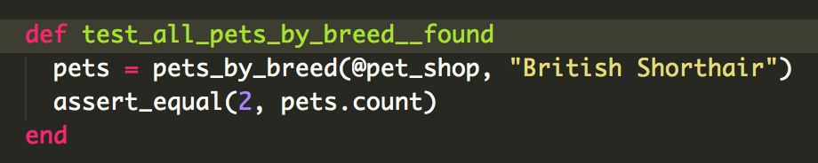

Result of successful test

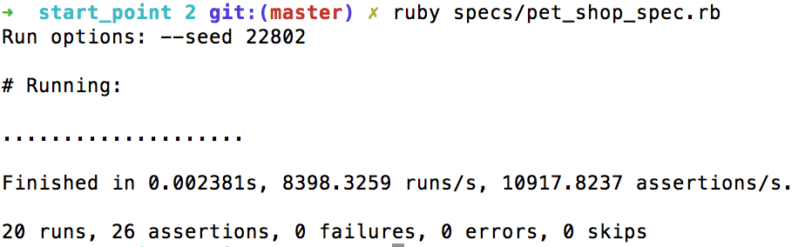

**Hashes**

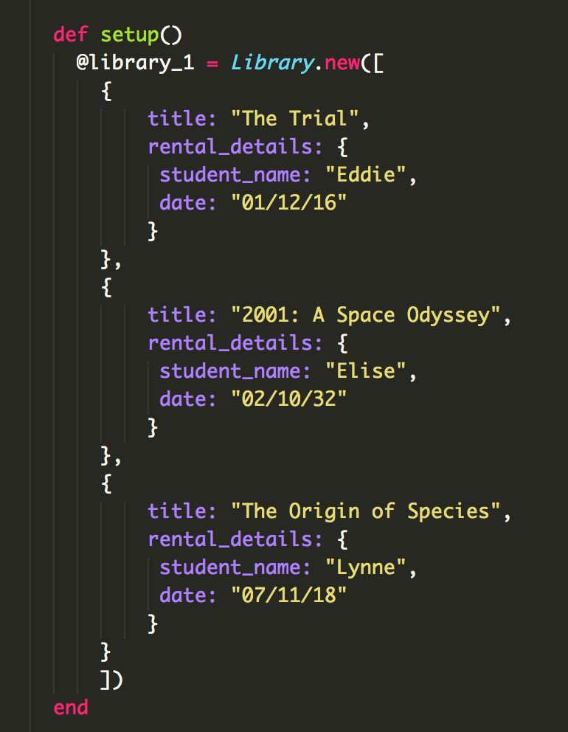

Search through library array for book title then return hash element

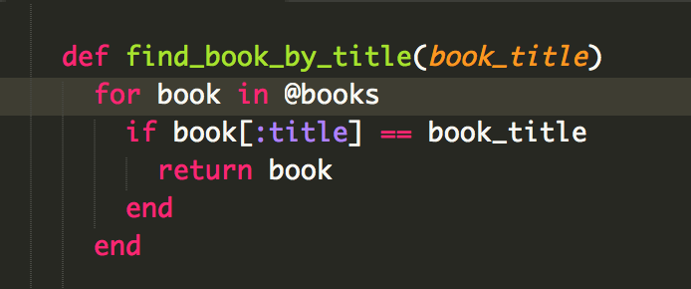

The result of the function running

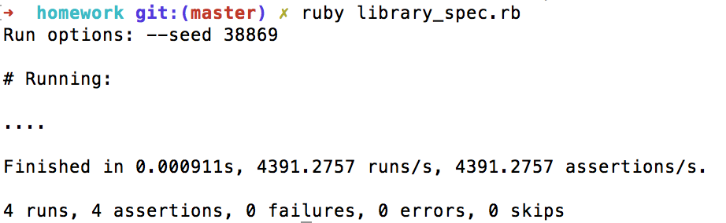

**Search data**

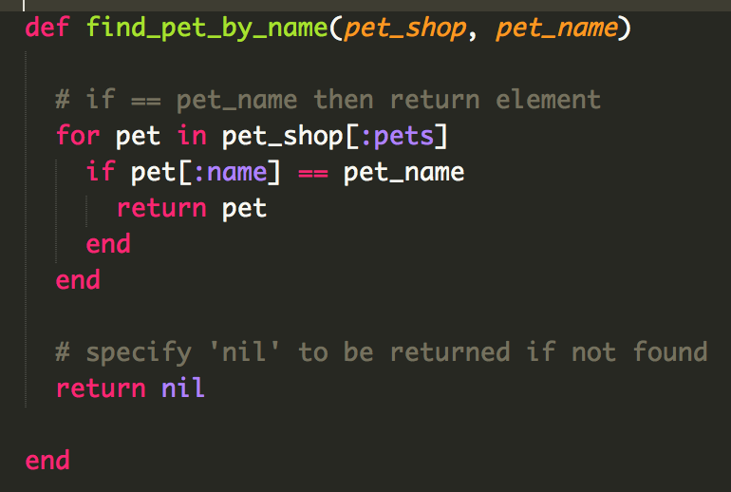

Search for a book by title and return the rental details

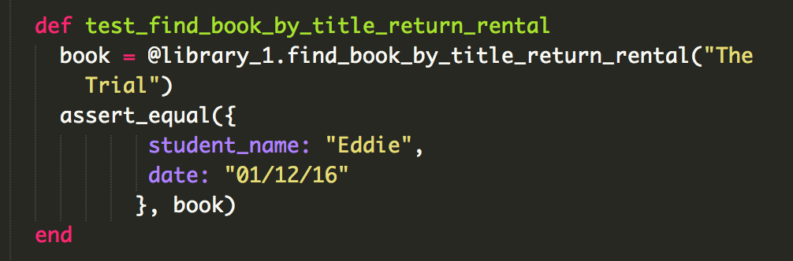

Test

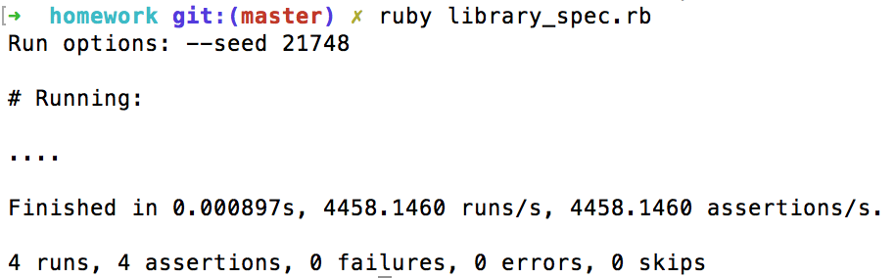

Searching database

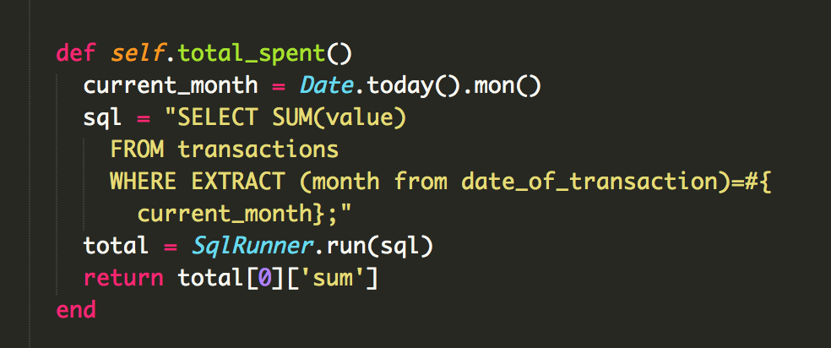

Result

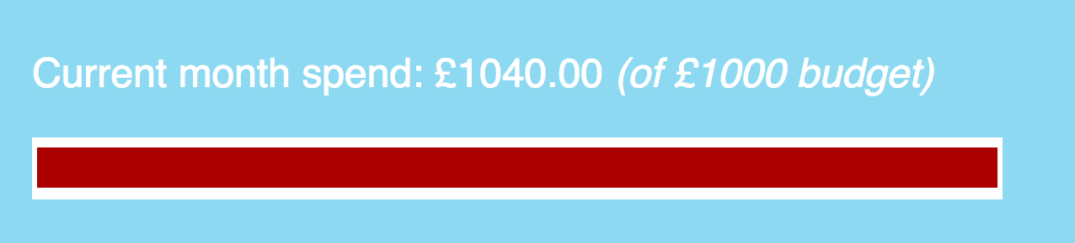

Sorting data by month

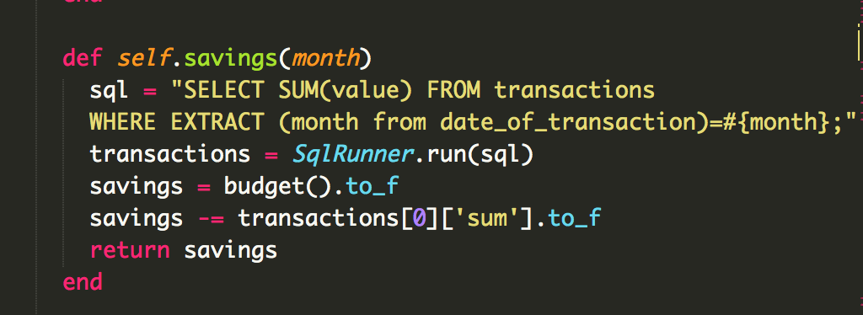

Result

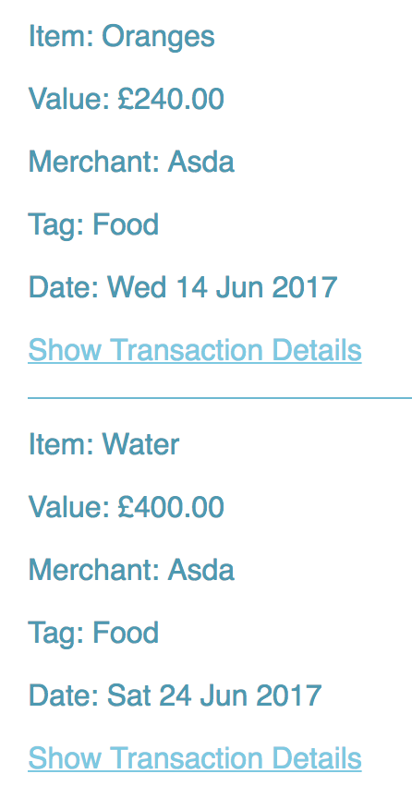

**Polymorphism**



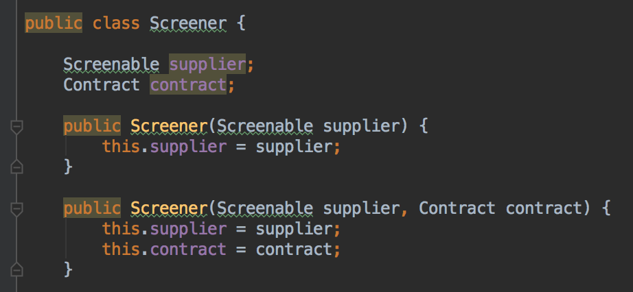

Pass in a supplier as a Screenable rather than a Supplier

**Inheritance Diagram**

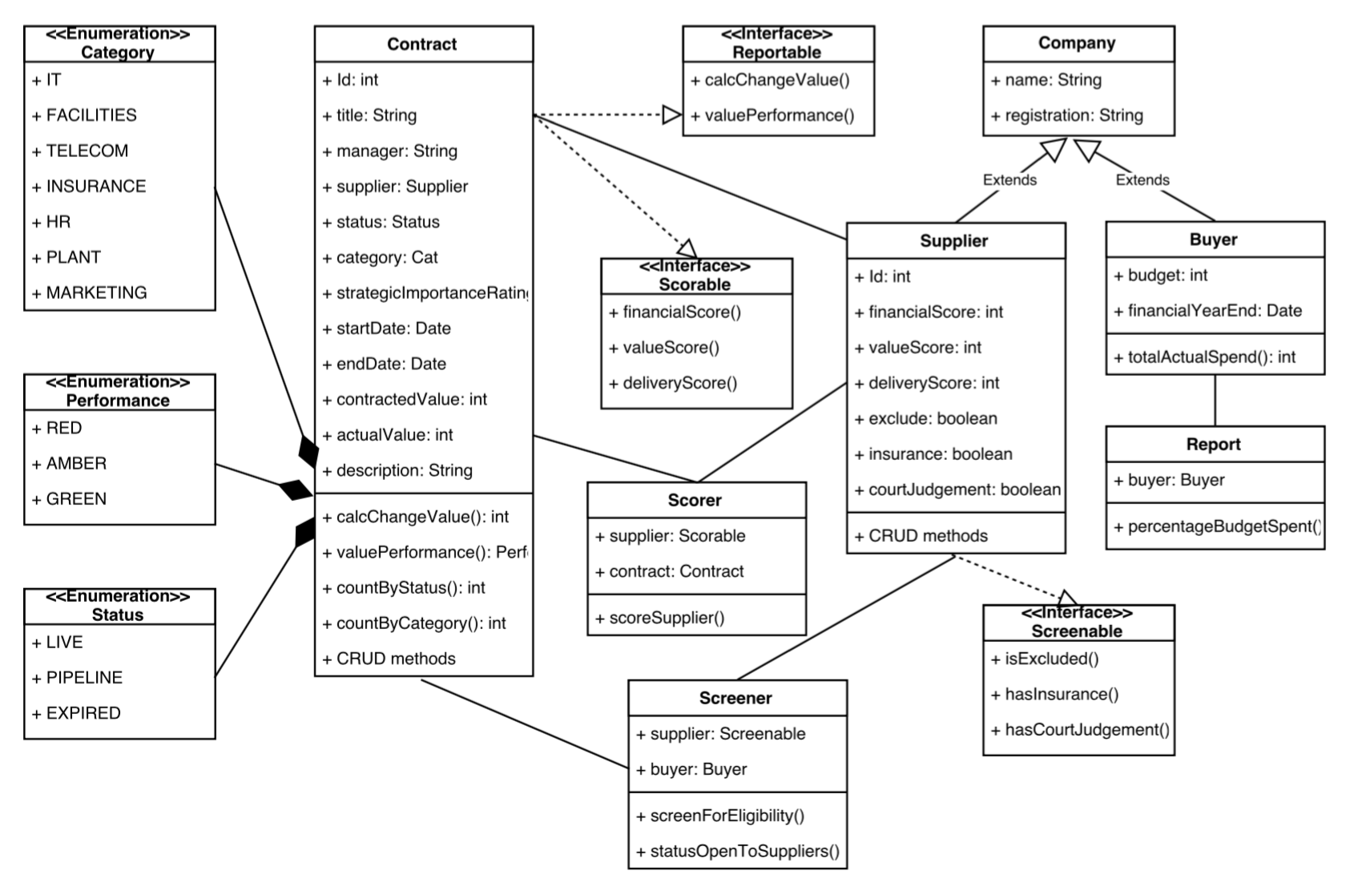

**Encapsulation**

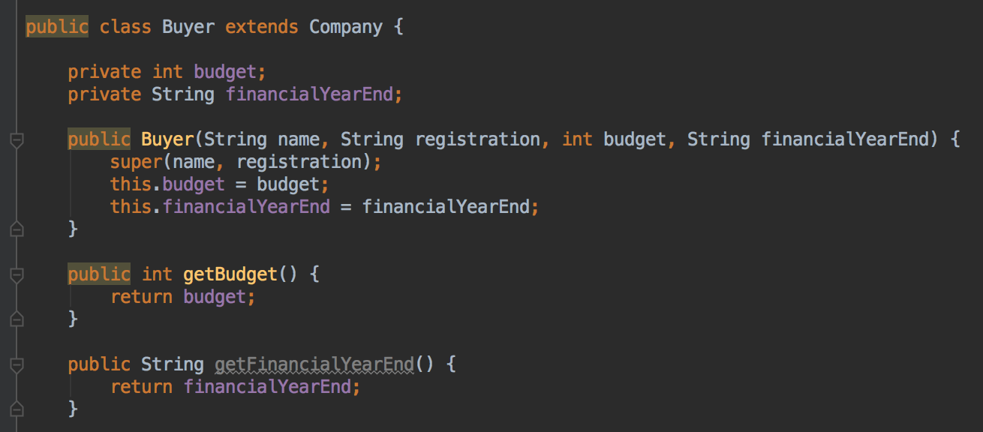

budget and financialYearEnd are declared as private and getters are used to access them.

**Inheritance in a Program**

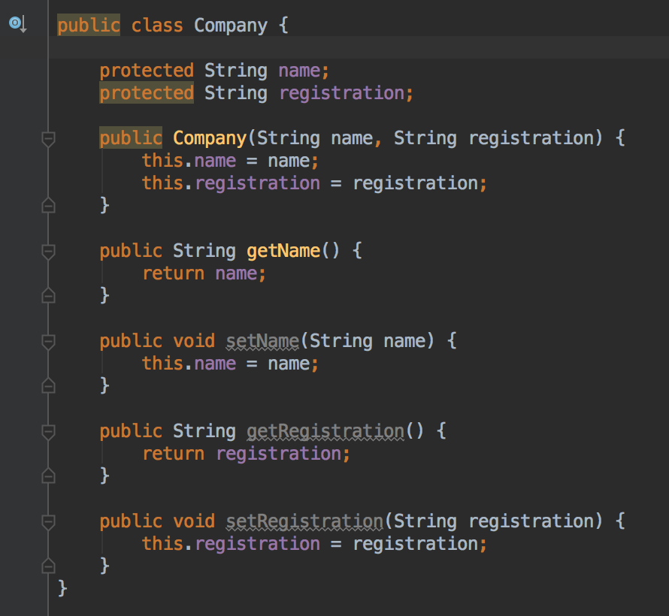

Supplier inherits name and registration from Company

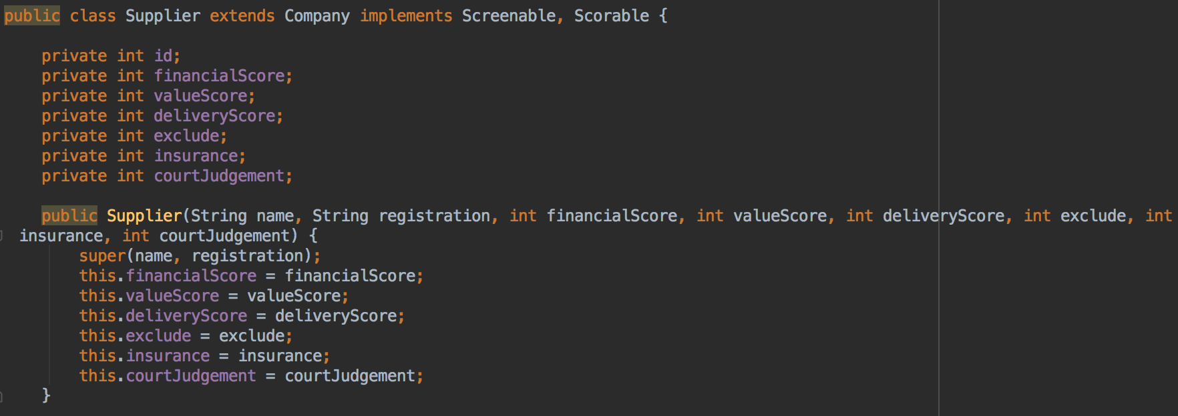

And is used to access SQL database

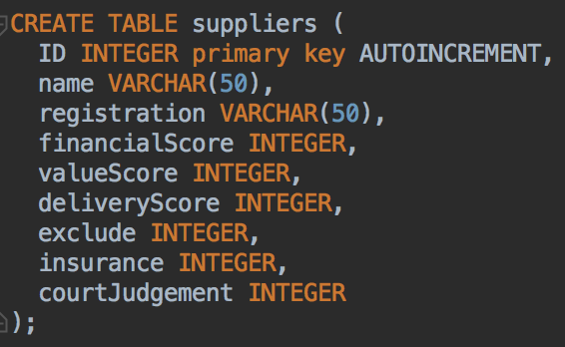

Method that accesses information from both the superclass and subclass



**Screenshot of one of my projects where I worked alone**

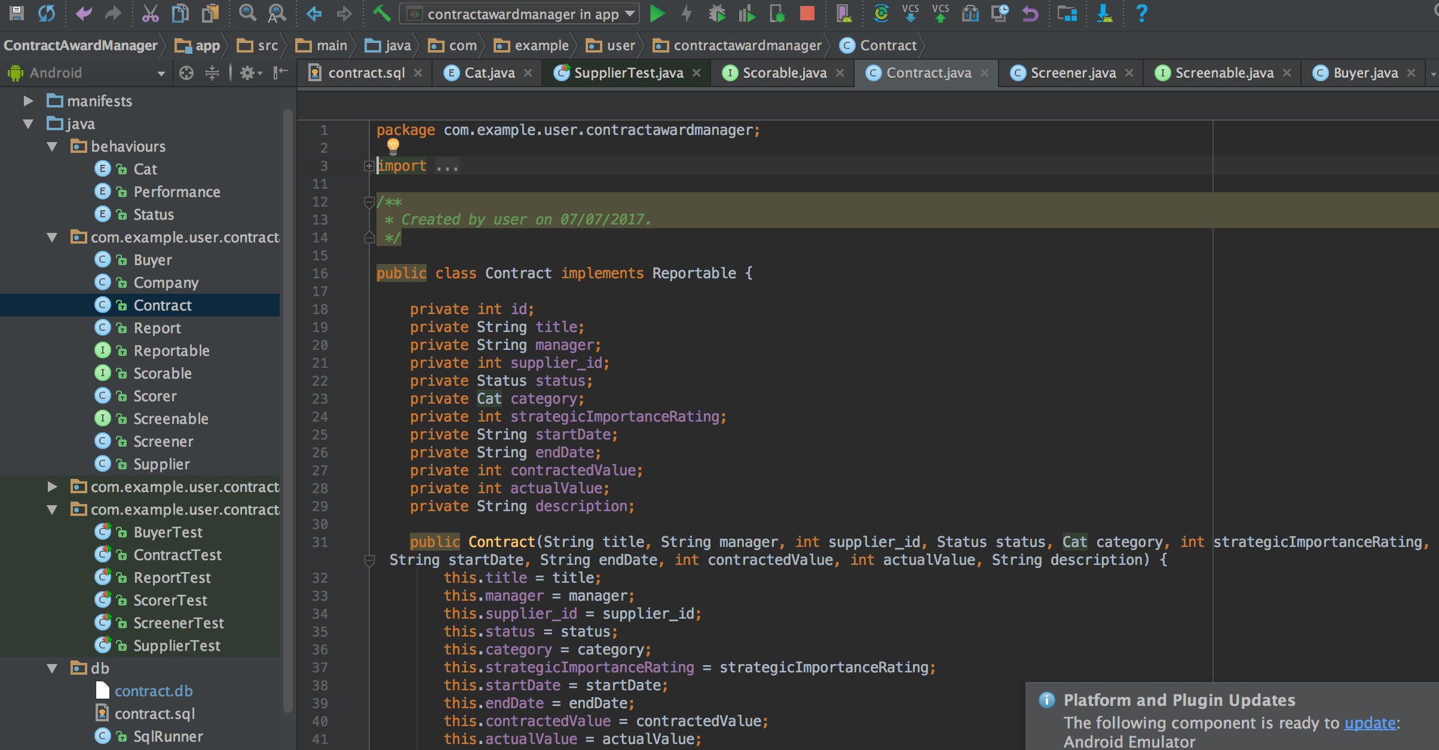

GitHub link

git@github.com:stephenedwardng/ContractAwardManager.git

Planning evidence

